YE16K16S13L3AA1
16Kx16 bits Embedded MTP Memory

General Description
YE16K16S13L3AA is an embedded MTP memory block fabricated in the SMIC 0.13 um Logic Low Leakage 1.5 V/ 3.3 V 1P8M Process. The memory is organized as 16K by 16-bit. They are featured with word write and word read memory IP. Peripheral circuits—including decoders, charge pumps, R/W controller, high-voltage switches and sense amplifiers—are integrated into the MTP IP core.

Features
- Word Read / Word Write Operation (differing from traditional chip erase)
- Smart Write Mode
- The smart write can reduce whole chip write time

Smart Write Mode
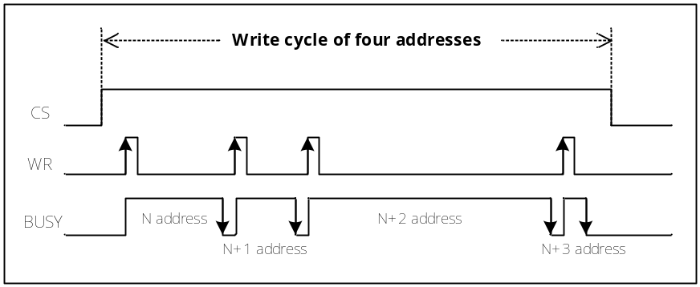 (For example)
The smart write mode has a BUSY signal which is the flag indicator. It will implement BUSY Check mechanism. When BUSY signal is pulled “low” from “high”, it represents the write operation at this address is completed. The data have certainly been written into embedded MTP memory.

According to the waveform above, the real write time is the duration of BUSY signal keeping “high”. The write time differs in length at every address. If writing the data again which is the same as current state (non-changed) at current address, the BUSY time may be merely 1us (min.). For example, at N+3 address, the current data is 55. Write 55 again.

Common Specification

Process | SMIC 0.13 um Logic Low Leakage 1.5 V/3.3 V 1P8M Process
Read Voltage | V_{DD1} :1.35V~1.65V / V_{DD2} : 1.8~3.6V
Write Voltage | V_{DD1} :1.35V~1.65V / V_{DD2} : 2.5~3.6V
Write Speed | Word Write Time (changed code) : 500us (typ.)
Write Speed | Word Write Time (non-changed code) : 1us (min.)
Read Speed | Byte Read Access Time : 40ns (typ.)  40ns (max) as VDD=2.6V~3.6V  100ns (max) as VDD=1.8V~2.5V
Read Speed | Read Cycle Time : 100ns (min.)  40ns (min) as VDD=2.6V~3.6V  100ns (min) as VDD=1.8V~2.5V
Standby Current | ISB1 < 10uA (for VDD1) ISB2 < 10uA (for VDD2)
Data Retention | 10 Years under 85℃
Operating Temperature | Tj = -40℃ to 85℃
Endurance | 1,000 Cycles

Pin Description¹
Pin name | Direction | Signal Level | Description
ADR[13:0] | I | V_{DD1} | Address input pin.
DIN[15:0] | I | V_{DD1} | Data input pin.
DOUT[15:0] | O | V_{DD1} | Data output.
CS | I | V_{DD1} | Chip selective input, active HIGH.
READ | I | V_{DD1} | Read enable input, active HIGH.
WR | I | V_{DD1} | Write enable input, active HIGH.
RESETB² | I | V_{DD1} | Reset chip input, active LOW.
REF0 | I | V_{DD1} | Define test mode of ref 0 read cycle.
REF1 | I | V_{DD1} | Define test mode of ref 1 read cycle.
CLEN | I | V_{DD1} | Define test mode of cell current measurement.
HVEN | I | V_{DD1} | Define write cycle with external high voltage supply.
BUSY | O | V_{DD1} | Flag indicating that internal write operation is on going or not.
WRFAIL | O | V_{DD1} | Flag indicating that internal write operation is out of time or not.
VPP | I | - | External high voltage supply
V_{DD1} | I | - | Power supply for V_{DD1}
V_{DD2} | I | - | Power supply for V_{DD2}
VSS | I | - | Ground
Notes:
- Need to multiplex all control, address and data signals to package pins to facilitate direct memory test.
- When RESETB is set to logic LOW, those READ, WR and CLEN inputs will be ignored and internal write cycle will be interrupt as well.

Recommended DC Operating Conditions (Tj = specified, Cload=1pF)
Parameter | Symbol | Min. | Typ. | Max. | Unit
Read Voltage | V_{DD1} | 1.35 | 1.5 | 1.65 | V
Read Voltage | V_{DD2} | 1.8 | 3.3 | 3.6 | V
Read Voltage | V_{PP} | V_{DD1}/ V_{DD2}/ V_{SS} / Floating |  |  | V
Write Voltage | V_{DD1} | 1.35 | 1.5 | 1.65 | V
Write Voltage | V_{DD2} | 2.5 | 3.3 | 3.6 | V
Write Voltage | V_{PP} | V_{DD1}/ V_{DD2}/ V_{SS} / Floating |  |  | V
Voltage of Reset | V_{DD1 reset} | 1.35 | - | - | V
Voltage of Reset | V_{DD2 reset} | 1.8 | - | - | V
HVEN Write Voltage | V_{DD1} | 1.35 | 1.5 | 1.65 | V
HVEN Write Voltage | V_{DD2} | 2.5 | 3.3 | 3.6 | V
HVEN Write Voltage | V_{PP} | TBD | TBD | TBD | V
Ground | V_{SS} | 0 | 0 | 0 | V
Measure Cell Current Voltage | V_{DD1} | 1.35 | 1.5 | 1.65 | V
Measure Cell Current Voltage | V_{DD2} | 2.5 | 3.3 | 3.6 | V
Measure Cell Current Voltage | V_{PP} | TBD |  |  | V

DC Electrical Characteristics (Tj = specified, VDD1/VDD2 = specified, VSS =0V, Cload=1pF)
Parameter | Symbol | Condition | Min. | Typ. | Max. | Unit
Read  (V_{DD1} Current) | IDR1 | f_{READ} = 1MHz | - | 0.3 | 0.6 | mA
Read  (V_{DD1} Current) | IDR1 | f_{READ} = 5MHz | - | 1.5 | 3.0 | mA
Read  (V_{DD2} Current) | IDR2 | f_{READ} = 1MHz | - | 0.01 | 0.02 | mA
Read  (V_{DD2} Current) | IDR2 | f_{READ} = 5MHz | - | 0.01 | 0.02 | mA
Read  (Vpp Current) | IPR | f_{READ} = 1MHz | - | 1 | 2 | uA
Read  (Vpp Current) | IPR | f_{READ} = 5MHz | - | 2 | 3 | uA
Write  (V_{PP}/ V_{DD1}/  V_{DD2} Current) | IDW1 | - | - | 0.4 | 0.8 | mA
Write  (V_{PP}/ V_{DD1}/  V_{DD2} Current) | IDW2 | - | - | 20 | 40 | mA
Write  (V_{PP}/ V_{DD1}/  V_{DD2} Current) | IPW | - | - | 1 | 2 | uA
HVEN Write  (V_{PP}/ V_{DD1}/  V_{DD2} Current) | IDH1 | - | - | - | 0.6 | mA
HVEN Write  (V_{PP}/ V_{DD1}/  V_{DD2} Current) | IDH2 | - | - | - | 8 | mA
HVEN Write  (V_{PP}/ V_{DD1}/  V_{DD2} Current) | IPH | - | - | - | 8 | mA
Standby Current (V_{DD1} Current) | ISB1 | - | - | - | 10 | uA
Standby Current (V_{DD2} Current) | ISB2 | - | - | - | 10 | uA
Standby Current (Vpp Current) | IPS | - | - | - | 1 | uA
Static Current (V_{DD1} Current) | IDS1 | - | - | - | 200 | uA
Static Current (V_{DD2} Current) | IDS2 | - | - | - | 10 | uA
Static Current  (Vpp Current) | IPT | - | - | - | 2 | uA

Read Peak Current
Parameter | Symbol | Slow  (V_{DD1}=1.35V;  V_{DD2}=2.5V @85℃) | Typical  (V_{DD1}=1.5V;  V_{DD2}=3.3V @25℃) | Fast  (V_{DD1}=1.65V;  V_{DD2}=3.6V@-40℃) | Unit
Read in Peak Current  (VDD1 Current) | IDRP1 | TBD | TBD | TBD | mA
Read in Peak Current  (VDD1 Current) | IDRP1 | TBD | TBD | TBD | ns
Read in Peak Current  (VDD2 Current) | IDRP2 | TBD | TBD | TBD | mA
Read in Peak Current  (VDD2 Current) | IDRP2 | TBD | TBD | TBD | ns

Write Peak Current
Parameter | Symbol | Slow  (V_{DD1}=1.35V;  V_{DD2}=2.5V @85℃) | Typical  (V_{DD1}=1.5V;  V_{DD2}=3.3V @25℃) | Fast  (V_{DD1}=1.65V;  V_{DD2}=3.6V@-40℃) | Unit
Write in Peak Current  (VDD1 Current) | IDWP1 | TBD | TBD | TBD | mA
Write in Peak Current  (VDD1 Current) | IDWP1 | TBD | TBD | TBD | ns
Write in Peak Current  (VDD2 Current) | IDWP2 | TBD | TBD | TBD | mA
Write in Peak Current  (VDD2 Current) | IDWP2 | TBD | TBD | TBD | ns

Truth Table
User Mode
Mode | CS | READ | WR | CLEN | REF0 | REF1 | RESETB¹ | HVEN | Vpp
Standby | L | L/H | L/H | L/H | L/H | L/H | H | L/H | V_{DD1} /V_{DD2} /Vss/ floating
Static | H | L | L | L | L | L | H | L | V_{DD1} /V_{DD2} /Vss/ floating
Read | H | H | L | L | L | L | H | L | V_{DD1} /V_{DD2} /Vss/ floating
Write | H | L | H | L | L | L | H | L | V_{DD1} /V_{DD2} /Vss/ floating

Test Mode
Mode | CS | READ | WR | CLEN | REF0 | REF1 | RESETB | HVEN | Vpp
Measure Current | H | L | L | H | L | L | H | L | TBD
REF0 | H | H | L | L | H | L | H | L | V_{DD1} /V_{DD2} /Vss/ floating
REF1 | H | H | L | L | L | H | H | L | V_{DD1} /V_{DD2} /Vss/ floating
HVEN Write | H | L | H | L | L | L | H | H | TBD
Notes:
- RESETB in H state only occurred in power on state.

Capacitance
Parameter | Symbol | Min. | Max. | Unit
Address/Control Input Pin Capacitance | CIN | - | 0.2 | pF
Data Input Pin Capacitance | CDIN | - | 0.2 | pF
Data Output Pin Capacitance | CDOUT | - | 0.1 | pF

Timing Parameters (Tj = specified, V_{DD1}/ V_{DD2}= specified, VSS =0V, Cload=1pF)
Parameter | Symbol | Condition | Min. | Typ. | Max. | Unit
Address/Data Setup Time | Tads |  | 0 | - | - | ns
Address/Data Hold Time | Tadh |  | 100 | - | - | ns
READ Access Time | Trac | 2.6V≦V_{DD2}≦3.6V | - |  | 40 | ns
READ Access Time | Trac | 1.8V≦V_{DD2}≦2.5V | - | - | 100 | ns
Read Cycle Time | Trc | 2.6V≦V_{DD2}≦3.6V | 40 | - | - | ns
Read Cycle Time | Trc | 1.8V≦V_{DD2}≦2.5V | 100 | - | - | ns
Setup Time from CS to READ | Tcsrs |  | 100 | - | - | ns
Measurement Current Wait Time | Tmcw |  | 1 | - | - | us
WR Pulse Width | Twpw |  | 100 | - | - | ns
Write Time (changed code) | Twr |  | - | 0.5 | - | ms
Write Time (non-changed code) | Twr |  | 1 | - | - | us
Write Recovery Time | Twrc |  | 0 | - | - | ns
RESETB Setup Time | Trsts |  | 0 | - | - | ns
Setup Time from RESETB to Another Control Pins | Trscs |  | 40 | - | - | ns
DOUT hold Time | Tdoh |  | 10 | - | - | ns
BUSY Access Time to WR | Tbas |  | - | - | 50 | ns
Notes:
- All signals that align together in the timing diagrams should be derived from the same clock edge.
- All timing measurements are from the 50% of the rising (falling) edge to 50% of the falling (rising) edge.
- All input waveforms have rising time (tr) and falling time (tf) of 2ns.
- Reading or writing another data are not allowed during busy cycle.
- WRFAIL signal keeps low in the beginning of internal write cycle. When write time is out, WRFAIL signal is pulled high and BUSY signal is pulled low to interrupt internal write cycle. WRFAIL signal will be clear by next WR rising edge or when CS goes low.

Timing Waveforms

User Mode
Reset Timing
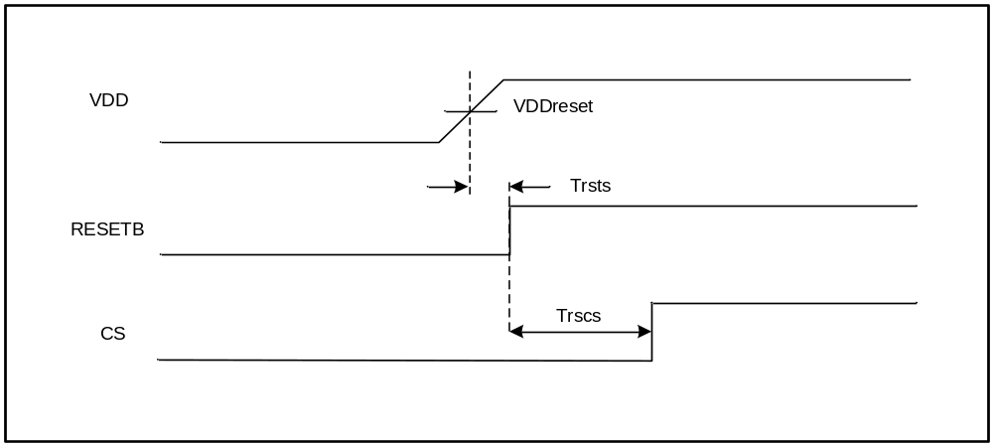

Read Cycle

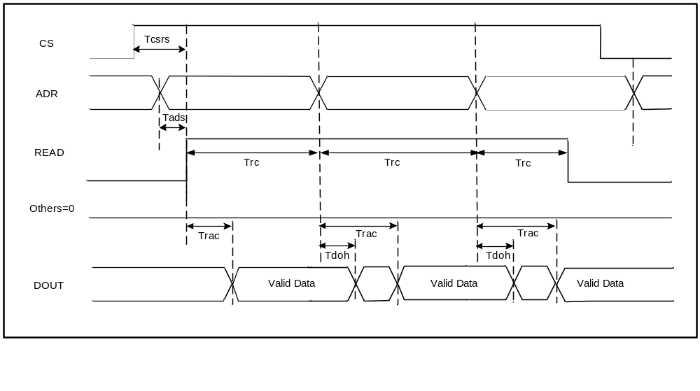

Write Cycle (Busy Check Mode)
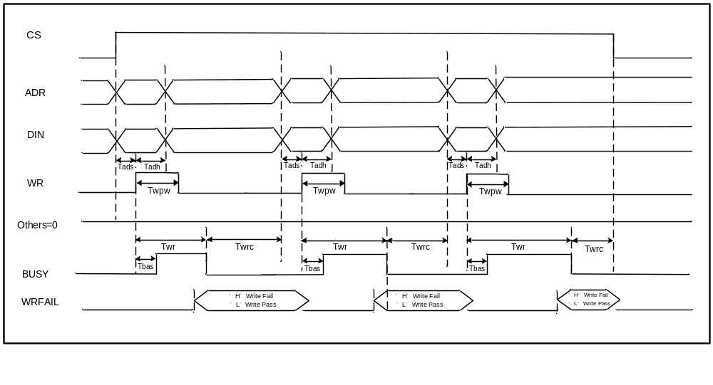
Notes:
1. If writing non-changed data again on current address, the BUSY time may be 1us (min.).
2.
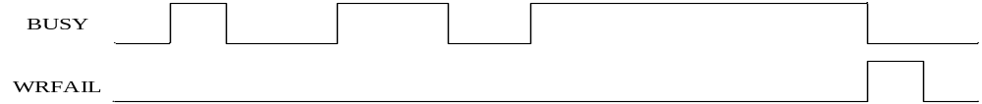
When busy time exceeds the maximum Twr, WRFAIL signal is pulled “high” and BUSY signal is pulled “low” to interrupt the write operation. WRFAIL signal will be clear by next WR rising edge or CS going low from high.

Test Mode
HVEN Write Cycle
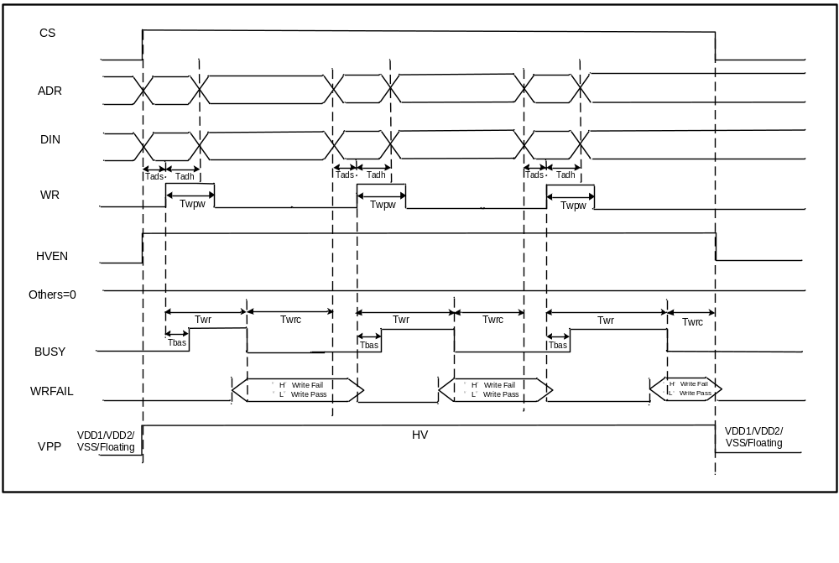
Notes:
1. If writing non-changed data again on current address, the BUSY time may be 1us (min.).
2. HV=specified as the typ. Vpp value of the HVEN Write Voltage in the Recommended DC Operating Conditions table.
3.
When busy time exceeds the maximum Twr, WRFAIL signal is pulled “high” and BUSY signal is pulled “low” to interrupt the write operation. WRFAIL signal will be clear by next WR rising edge or CS going low from high.

Measure Current Cycle
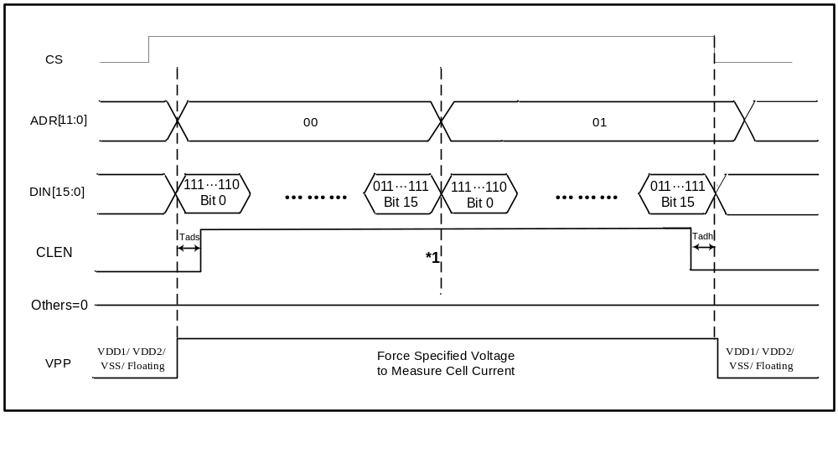
Notes:
* Cell current measurement:
- The external high voltage supply pin (Vpp) needs to be tied to IO pad to force voltage as the Vpp value of measure cell current voltage in the Recommended DC Operating Conditions table.
- ADR[14:0] is used to select byte. There is only one of DIN[15:0] buses indicating to the corresponding IO to be pulled as logic “L” at a time and others are logic “H” as below table. Thus it can be measured the cell current during CLEN high active period. For example, one address 00 is selected. When DIN[15:0] is 111…110, it can be measured for the cell current of bit0 at this address. The rest may be deduced by analogy. When DIN[15:0] is 011…111, it is for the cell current of bit15.

 | DIN 15 | DIN 14 | DIN 13 | DIN 12 | … | DIN 4 | DIN 3 | DIN 2 | DIN 1 | DIN 0
Bit0 | 1 | 1 | 1 | 1 | … | 1 | 1 | 1 | 1 | 0
Bit1 | 1 | 1 | 1 | 1 | … | 1 | 1 | 1 | 0 | 1
Bit2 | 1 | 1 | 1 | 1 | … | 1 | 1 | 0 | 1 | 1
Bit3 | 1 | 1 | 1 | 1 | … | 1 | 0 | 1 | 1 | 1
Bit4 | 1 | 1 | 1 | 1 | … | 0 | 1 | 1 | 1 | 1
: | : | : | : | : |  | : | : | : | : | ;
Bit12 | 1 | 1 | 1 | 0 | … | 1 | 1 | 1 | 1 | 1
Bit13 | 1 | 1 | 0 | 1 | … | 1 | 1 | 1 | 1 | 1
Bit14 | 1 | 0 | 1 | 1 | … | 1 | 1 | 1 | 1 | 1
Bit15 | 0 | 1 | 1 | 1 | … | 1 | 1 | 1 | 1 | 1

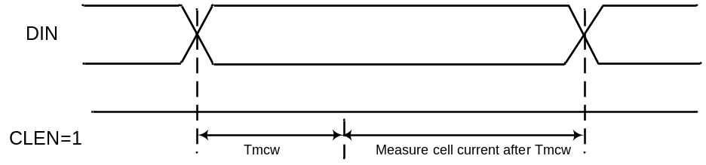

REF0 Read Cycle
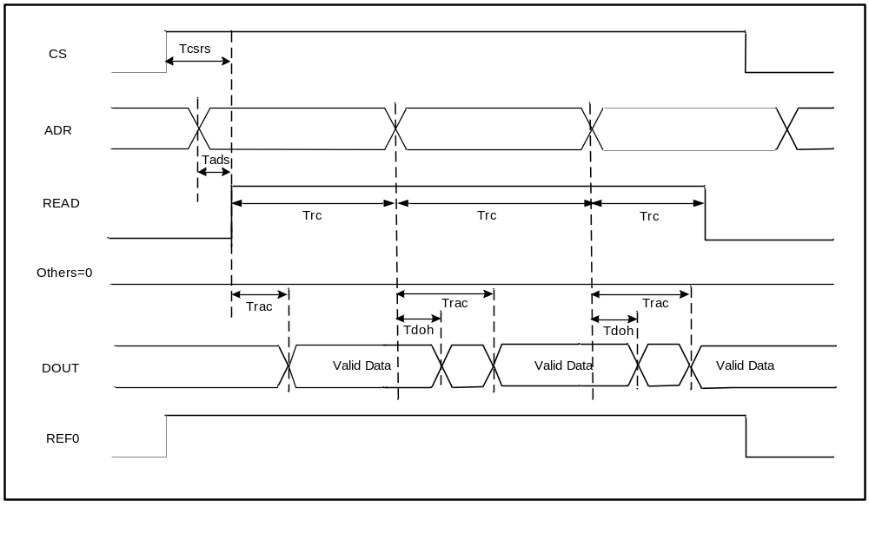

REF1 Read Cycle
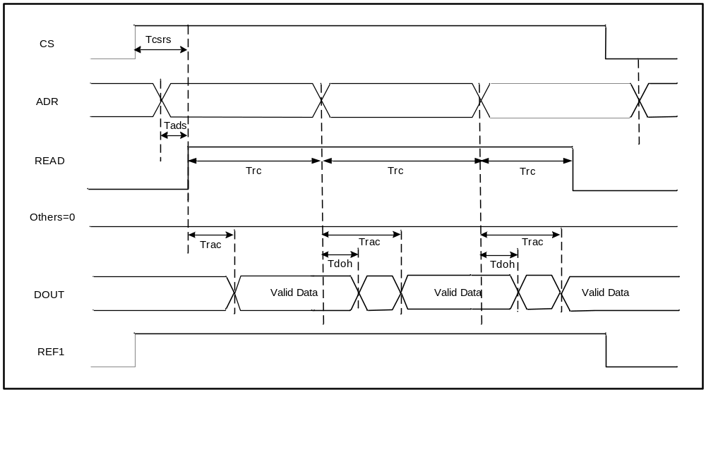

Update history:
Date | Rev |  | What | Who
2014/04/10 | A00 | 0.1 | Initial draft | Nick Chen

Warning:
The specification obtained arrives from individual testing result before integration; it has possibility to have the difference because of the mutual disturbing effect after integration. Therefore, the user must precede the full test and verification to conform the function and the reliability after integration. After the confirmation, and does not have any problem, it can enter the pilot run then the production run. YMC will not be responsible for the related responsibility and loss, if the procedure does not pass through the full test and verification.

